|  |  |  |  |  |  |
| --- | --- | --- | --- | --- | --- |
| **Name** | Rajan Kumar | | | | |
| **Email ID** | [Rajan24u@gmail.com](mailto:Rajan24u@gmail.com) | | | | |
| **Reference** | JLC/Jul18/CapReport | **Issue** | 01 | **Date** | 06 Oct 2018 |

# Introduction

This report have been prepared as part of final submission for the JLC Bootcamp July18 Course Certification Capstone Project.

## Project Brief

Amazon has risen concerned about sourcing of the below ASINs sold by us:

At Mobicom, you are a business analyst and have been urgently called into a meeting with the marketing head and retention manager. The agenda of this meeting is to discuss the results of Industry survey reports that have been just released. In response to these reports, senior management at Mobicom is concerned that the market environment of rising churn rates and declining ARPU will hit them even harder as churn rate at Mobicom is relatively high. Currently they have been focussing on retaining their customers on a reactive basis when the subscriber calls in to close the account. But this alone does not seem to be enough and the management team is keen to take more initiatives on this front. One of these is to roll out targeted proactive retention programs, which include usage enhancing marketing programs to increase minutes of usage (MOU), rate plan migration, and a bundling strategy among others. To be able to effectively drive these retention strategies, a few key questions of interest require urgent attention and you been given the task of showcasing data based insights and recommendations relating to subscriber churn.

Churn Market Survey Report

Mobile operators who lead in loyalty outperform their competition in network and service quality, as well as in customer care, according to the 2014 Acquisition and Retention Study Report from Nokia. While retention drivers vary by market maturity, delivering excellent quality keeps customers happy and loyal. The study results also show that churn continues to keep operators on their toes with 40% of customers globally planning to switch provider in the next 12 months. Cost and billing plays a key role across markets when deciding to stay with an operator, but is specifically important for emerging markets where 49% of customers consider it to be the most important factor when deciding to stay with an operator, with network and service quality following at 25%. When it comes to data usage, the number of subscribers experiencing problems is high. Among the problems they report are slow download speeds (20%), data throttling (17%) and applications that don’t work (16%). Another key finding of the 2014 Acquisition and Retention Study Report is that recommendations from family and friends have gained in importance in the decision to switch operators. Subscribers who have switched operators in recent months reported two key information sources in their decision: the Internet and recommendation of family and friends.

Another report by Ovum forecasts a falling ARPU, which will continue to decline across all markets.

Proactive Retention Strategies

Usage based promotions to increase minutes of usage (MOU) for both voice and data. It is an accepted fact that low usage and high churn go hand in hand.

Rate Plan Migration is a strategy to move customers from non-optimal plans to optimal plans as it has been observed that subscribers on non-optimal rate plans have significantly higher odds of churn relative to subscribers on optimal rate plans.

Offer bundling and churn have been found to be negatively correlated. A family bundle is an option that is being considered especially in the light of one of the observations from the survey that referrals from family and friends are a deciding factor for switching carrier.

Definitions

*Bundling* - A bundling strategy involves offering several products/services for sale as one combined product (e.g., package deal), using demand for the dominant product to sell a secondary offer. This combined product is offered at a discount price so that it is cheaper to buy the bundle than products separately.

*Optimal rate plan* - A post-paid wireless rate plan typically includes a fixed number of voice minutes that a customer can use per month. Usage exceeding the monthly allowance is called overage and is charged at a premium per-minute rate. Unless customers have a good understanding of their historical usage patterns and have the ability to predict their future wireless needs accurately, selecting an optimal rate plan to subscribe can be a challenging task. Conceptually, non-optimal rate plan subscribers could have saved money by switching to other more suitable plans to minimize overage. Specifically, customer’s rate plan suitability is determined based on their actual voice usage, the monthly rate of their selected plans, and the associated overage charges. *Given that rate plan is not available on the data file, a proxy for non-optimal rate plan could be higher overage revenue as a percentage of total revenue*.

*Artificial churn/spinners or serial churners*“Artificial” churn may be encouraged by so called “spinners”, who disconnect and reconnect to the same network by taking advantage of offers available.

Top Line Questions of Interest to Senior Management:

1. What are the top five factors driving likelihood of churn at Mobicom?
2. Validation of survey findings. a) Whether “cost and billing” and “network and service quality” are important factors influencing churn behaviour.  b) Are data usage connectivity issues turning out to be costly? In other words, is it leading to churn?
3. Would you recommend rate plan migration as a proactive retention strategy?
4. What would be your recommendation on how to use this churn model for prioritisation of customers for a proactive retention campaigns in the future?
5. What would be the target segments for proactive retention campaigns? Falling ARPU forecast is also a concern and therefore, Mobicom would like to save their high revenue customers besides managing churn. Given a budget constraint of a contact list of 20% of the subscriber pool, which subscribers should prioritized if “revenue saves” is also a priority besides controlling churn. In other words, controlling churn is the primary objective and revenue saves is the secondary objective.

## Dataset Location

All data files referenced in project are in the Jigsaw lab at:

“C\DS Fullstack\Assignments\Graded Assignment\09 - Capstone Project and Certitication“

The data set named “telecomfinal.csv” is present here “C\Data Science with R\Assignments\Graded Assignment\Topic 13 – Capstone Project “

Data dictionary named “data_documentation.xls” is present here “C\Data Science with R\Assignments\Graded Assignment\Topic 13 – Capstone Project “

An approach note, “Final Case Study.pptx” is present here “C\Data Science with R\Assignments\Graded Assignment\Topic 13 – Capstone Project “

A sample data quality report named “Sample Data quality report.xlsx” is present here “C\Data Science with R\Assignments\Graded Assignment\Topic 13 – Capstone Project “

## Model File Location

The Model files of this project are in the Jigsaw lab at:

“C:\Jigsaw17890\Capstone_Project_02Oct18”

The final model file name is: “capstone_code_final_submission_r1”

# Model and Results

R-program model “capstone_code_final_submission_r1” has been created to derive the answer for the Top Line Questions.

## Model Summary

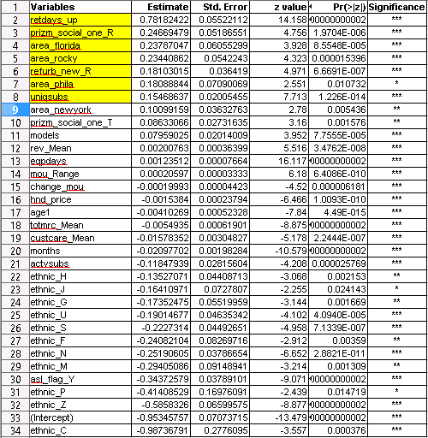

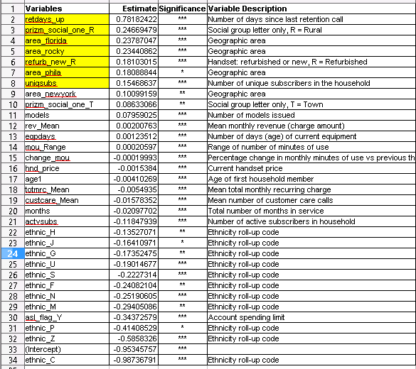

## Kappa Matrix

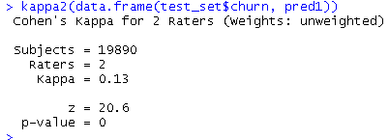

## Confusion Matrix

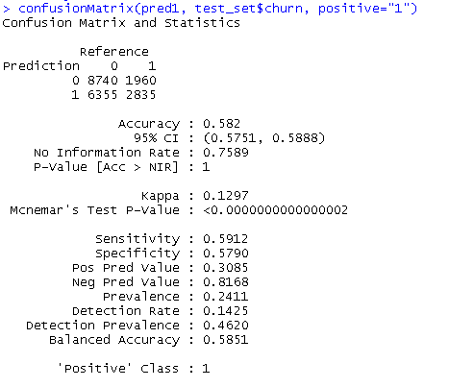

## ROCR Curve

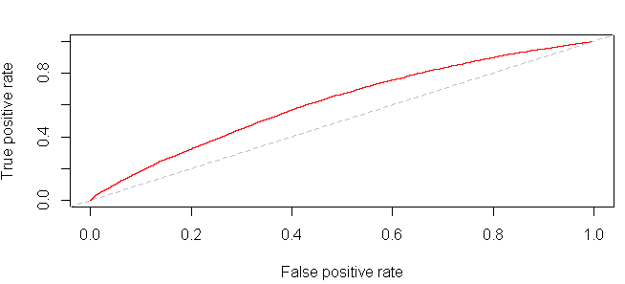

## AUC

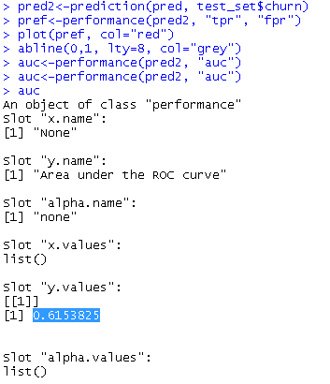

## Gain Chart

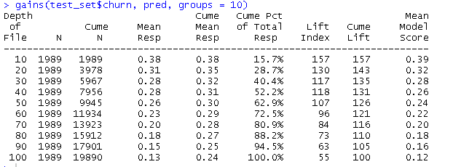

## Probability Distribution



# Discussion

## Top Line Questions – Answer

1. What are the top five factors driving likelihood of churn at Mobicom?

**ANS:** Top five factors are:

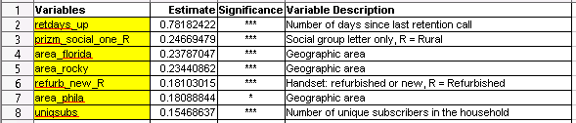

1. Validation of survey findings. a) Whether “cost and billing” and “network and service quality” are important factors influencing churn behaviour.  b) Are data usage connectivity issues turning out to be costly? In other words, is it leading to churn?

**ANS:** As “DROP_BLK_MEAN” and other related variables for “network and service quality” and “connectivity issues” do not figure in the model summary, therefore is NOT an important factor.

1. Would you recommend rate plan migration as a proactive retention strategy?

**ANS:** As “TOTMRC_MEAN” figure in the model summary, though with a beta coefficient which can give 50% probability, therefore YES we should recommend rate plan migration as a proactive retention strategy

1. What would be your recommendation on how to use this churn model for prioritisation of customers for a proactive retention campaigns in the future?

**ANS:** Gain Chart and Probability Distribution can be used for customer segmentation for proactive retention campaigns. The above Gain Chart suggest, for the Test dataset, 20% of data covers customer with 30% of customer who are more likely to leave. Those 20% customers can be extracted using Probability Distribution.

1. What would be the target segments for proactive retention campaigns? Falling ARPU forecast is also a concern and therefore, Mobicom would like to save their high revenue customers besides managing churn. Given a budget constraint of a contact list of 20% of the subscriber pool, which subscribers should prioritized if “revenue saves” is also a priority besides controlling churn. In other words, controlling churn is the primary objective and revenue saves is the secondary objective.

**ANS:**

The above Gain Chart suggest, for the Test dataset, 20% of data covers customer with 30% of customer who are more likely to leave. Those 20% customers can be extracted using Probability Distribution.